Enviaudits Ltd
FSC® Group Chain of Custody Scheme
Membership Registration

This is to confirm that:
Varsity Packaging Limited
Unit 10, Commerce Park, Brunel Rd, Theale, RG7 4AB

Has been assessed and certified as meeting the requirements of the Forest Stewardship Council® chain of Custody standards;
FSC-STD-40-004 V3-1, Chain of Custody Certification
FSC-STD-40-003 V2-1, EN COC Certification of Multiple sites
FSC-STD-50-001 V2-1 Use of FSC® trademarks

Chain of Custody number: INT-COC-005535-106 INT-CW-005535-106
Licence code: FSC-C007915

Scope: Purchase, storage and sale of paper and board with outsourced activities

Products: P3 Paperboard, P3 Paperboard, P3 Paperboard, P3 Paperboard, P3 Paperboard

Start Date: 08/06/2007 | Expiry Date: 14/06/2031

Issue number: 2

Full listing: https://info.fsc.org/details.php?id=a0240000008JIyxAAG&type=certificate

Greg Moore
Director, Enviaudits Ltd

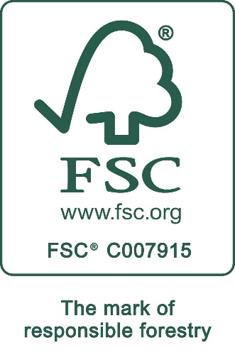

Management of the FSC® certification programme (Group Scheme) is by Enviaudits, Georgian House, 34 Thoroughfare, Halesworth, Suffolk, IP19 8AP, United Kingdom. www.enviaudits.co.uk
Group certification by Interface NRM Limited, e-Innovation Centre, University of Wolverhampton, Priorslee, Telford, Shropshire, TF2 9FT, United Kingdom. www.interface-nrm.co.uk

